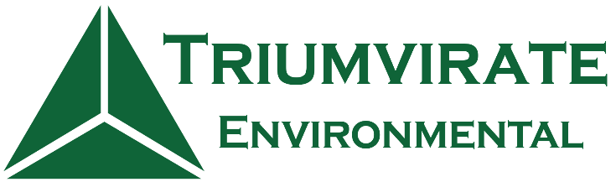

**Environmental+ Warehouse Laborer & CDL Driver Hiring Event!**

Please join Triumvirate Environmental for an Environmental+ Warehouse Laborer & CDL Driver Hiring Event!

Date & Time: Thursday, March 18, 2021 from 5:00 P.M. EST to 6:00 P.M. EST.

RSVP: <https://www.eventbrite.com/e/environmental-warehouse-laborer-and-cdl-driver-hiring-event-tickets-145256769909>

Triumvirate Environmental is one of the largest environmental services firms in North America. Triumvirate provides leading institutions in the higher education, life sciences, healthcare, and industrial sectors with diverse services and advice to assist them with compliance management.

Our passionate employees provide a high level of service to support the innovative work of our customers – leading companies in the Life Sciences, Healthcare, Education, and Industrial markets. We pride ourselves on truly understanding our clients’ business, anticipating their needs, and achieving their goals.

Please join us for this one of a kind Virtual Career Fair that will provide you insight about Triumvirate and our Entry-Level career opportunities in Environmental Services.

This event is 100% remote and online. After you register for the event a member of Triumvirate's Talent Acquisition team will reach out to you with full instructions on how to attend the event.

Where we hire:

Somerville, MA - Lowell, MA - Cranston, RI - Newington, CT - Astoria, NY - Philadelphia, PA - West Easton, PA - Jeannette, PA - Baltimore, MD - Ashland, VA - Raleigh, NC - Covington, GA - Orlando, FL - Davie, FL - La Verne, CA - Contrecoeur, QC.

Please contact careers@triumvirate.com with any questions or concerns.

Please visit our website for more information about Triumvirate!

<https://www.triumvirate.com/careers>

***Actively hiring for Environmental Laborers, Environmental Technicians, Field Technicians, Warehouse Specialists, Warehouse Coordinators & CDL Class A & B Drivers!***