**Breaktime Director of Programming**

***Full-Time, Salaried***

Organization Overview

Breaktime ([www.breaktime.org](http://www.breaktime.org)) is a non-profit social enterprise started out of Harvard University that elevates young adults out of homelessness through supported transitional employment and empowerment. Our aim is to prevent long-term chronic homelessness through early intervention that provides young adults experiencing homelessness with pathways to launching a career and becoming leaders within our community. We believe that every young adult experiencing homelessness deserves the chance to take control of their own careers and destinies and, ultimately, find their way home.

Breaktime’s specific niche is as a transitional employer, providing the needed stepping stone between foundational training programs run by other nonprofits and jobs in the broader workforce. In response to the global COVID-19 pandemic, Breaktime has launched the Double Impact Initiative to create paid employment opportunities for young adults experiencing homelessness in serving and strengthening our community. To date, our employees in the Double Impact Initiative have served over 30,000 meals to communities in need. Breaktime is also developing the Breaktime Cafe at 170 Portland Street, which will be a talent hub, community space, and coffee shop that will offer supported transitional employment.

Breaktime’s work has been featured in the Boston Globe, NBC, Boston25 News, and more. Breaktime is backed by the City of Boston, Liberty Mutual Foundation, Blackrock, the Boston Foundation, and more.

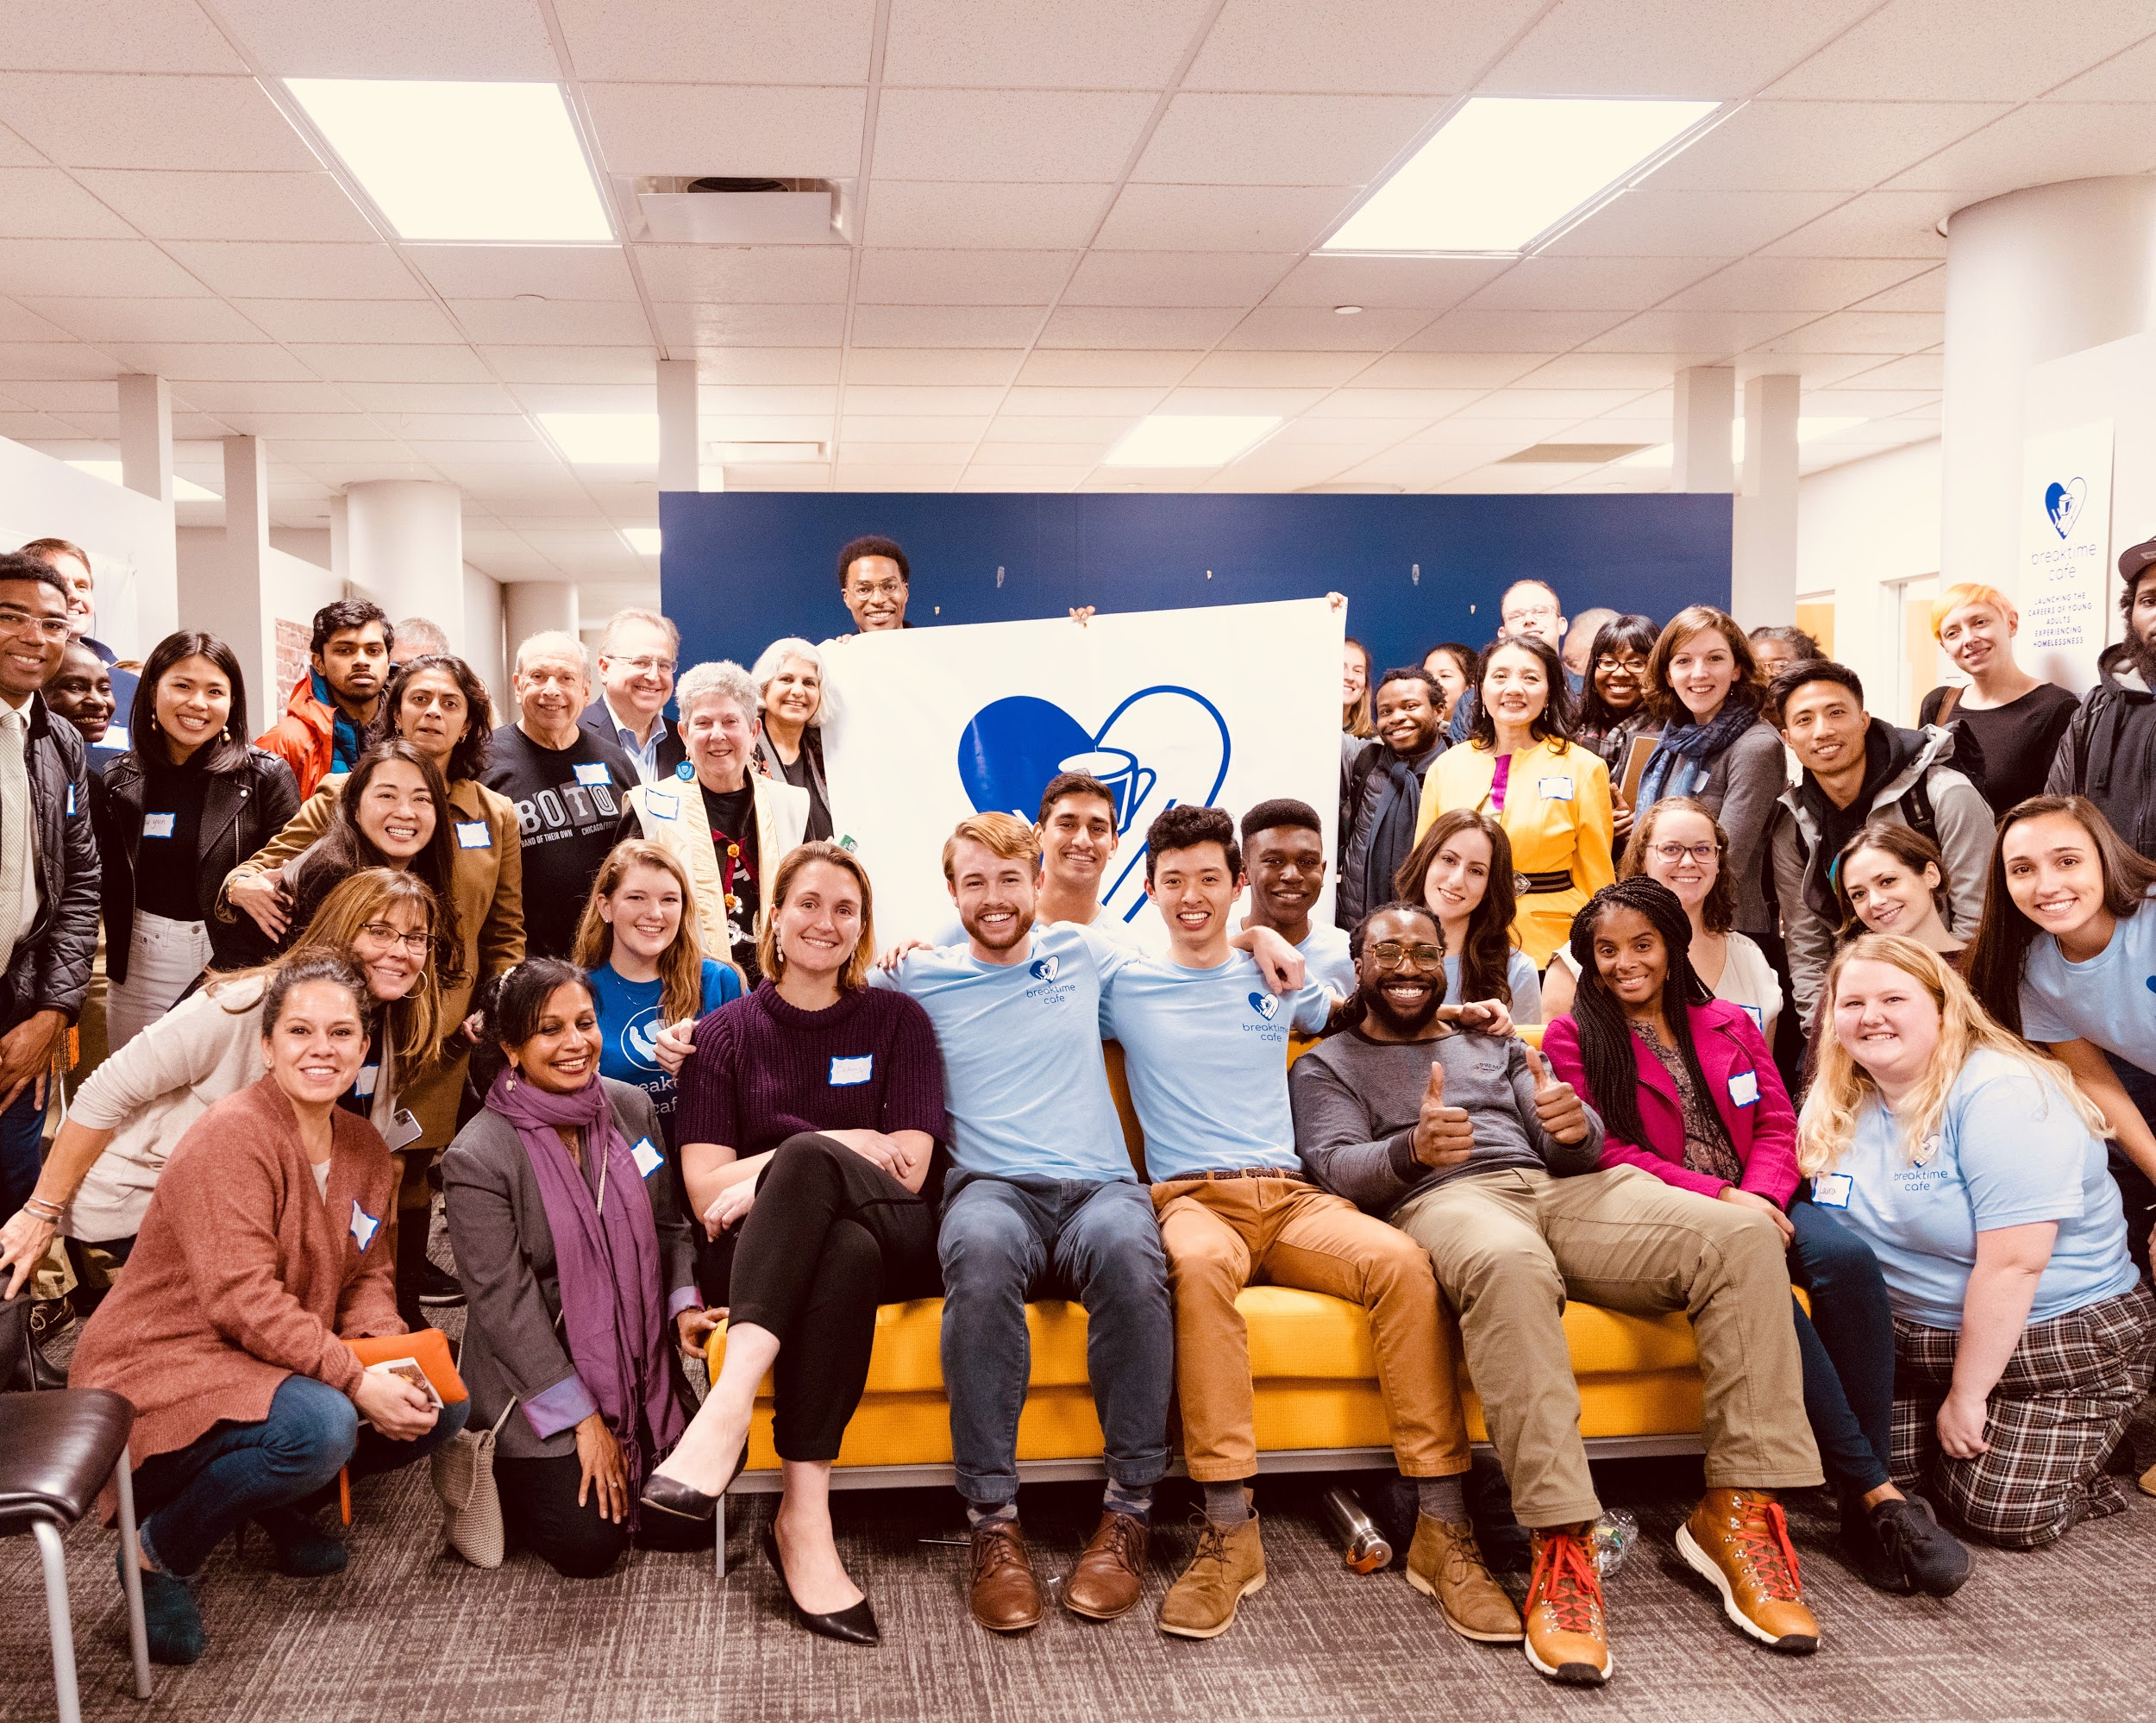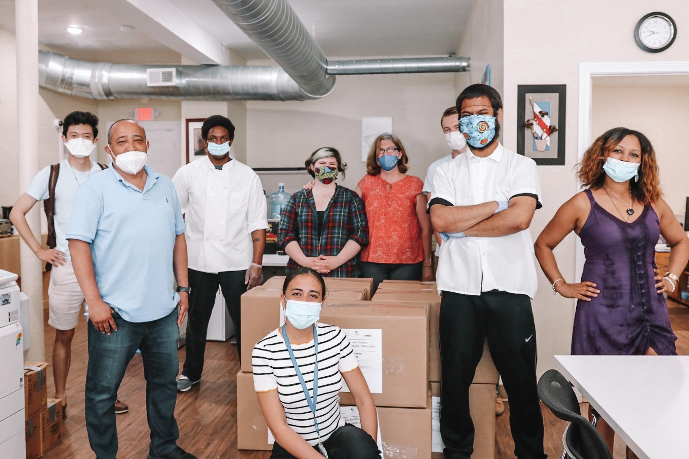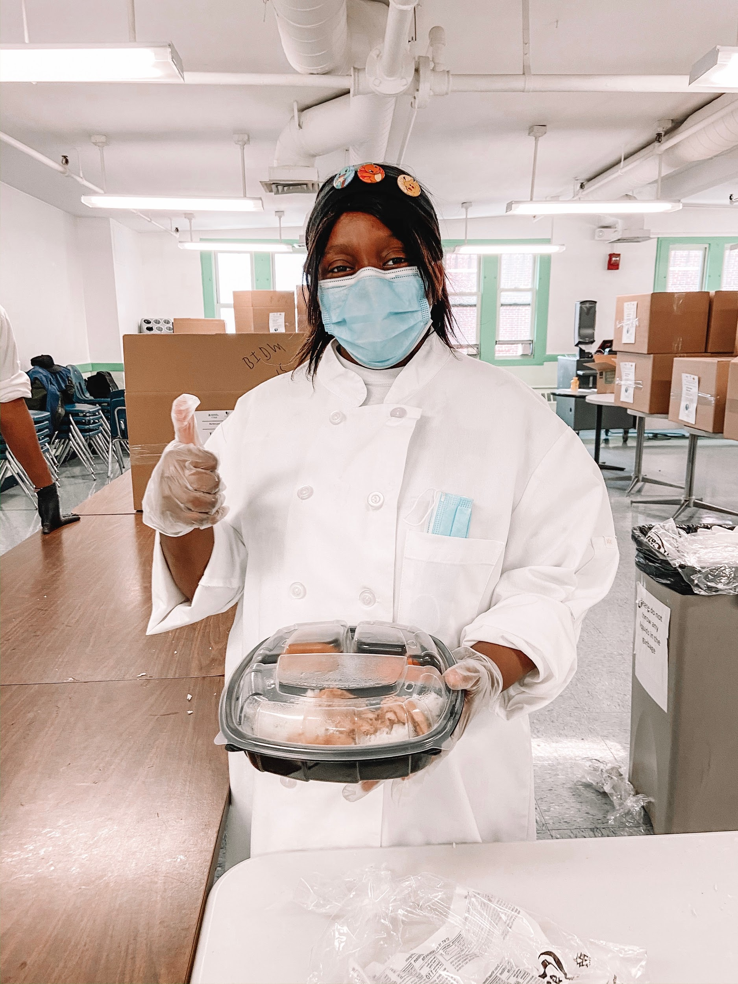

Roles and Responsibilities

* **Lead** the Breaktime Programming Team and oversee recruiting and onboarding of young adults into our programs, conducting/coordinating biweekly individual check-ins, operating programming sessions (specifically relating to the topic of financial empowerment), ensuring all associates attend program sessions and fill out weekly feedback/check-in surveys, coordinating with program managers and case managers who work with our young people, and mapping out a path to success and stability for each individual
* **Launch** a new youth-initiated mentor program to empower the trusted individuals in our associates’ networks with the training they need to be effective mentors and one-on-one coaches for job readiness, financial literacy, and professional development
* **Innovate** new strategies for scaling our programs to elevate more young people out of homelessness while improving the quality of each individual’s experience with Breaktime
* **Build** up existing non-profit partnerships and initiate new partnerships in order to strengthen the continuum of care Breaktime provides each associate, augment our associates’ access to and knowledge of helpful resources, and develop new pipelines for long-term, sustainable opportunities

Job Requirements

* At least two years of experience working to develop and implement youth-oriented programming for non-profits *(can be in a full-time, part-time, or volunteer capacity)*
* At least two years of experience working directly with vulnerable or at-risk youth *(can be in a full-time, part-time, or volunteer capacity)*
* At least one year of experience leading a team of three or more people *(can be in a full-time, part-time, or volunteer capacity)*
* Exceptionally strong written and verbal communication skills
* Exceptionally strong organization and leadership skills--a demonstrated ability to take initiative, stay organized, delegate work, and support team members in meeting responsibilities
* Advanced proficiency with Google Sheets and Google Forms

Preferred skills

* At least one year of experience working with a startup
* An adaptive, innovative, compassionate approach to leadership
* Significant experience with Salesforce

Next Steps

**To express interest in this position, please contact Tony Shu at** [**tony@breaktime.org**](mailto:tony@breaktime.org) **and Connor Schoen at** [**connor@breaktime.org**](mailto:connor@breaktime.org) **with a cover letter and resume. You may also email Tony and Connor with any additional questions.**